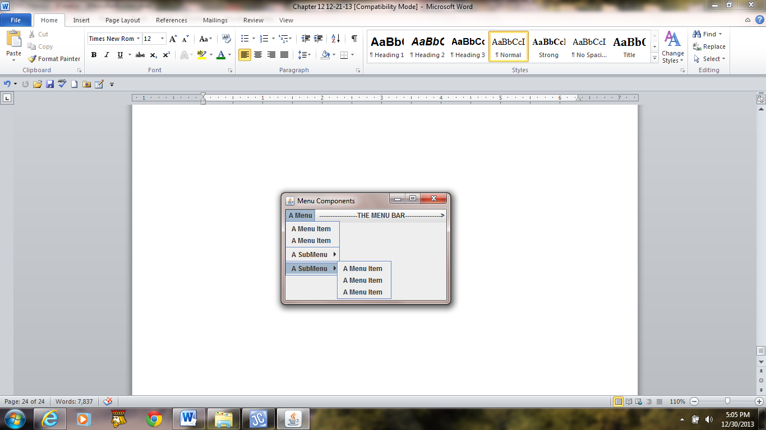 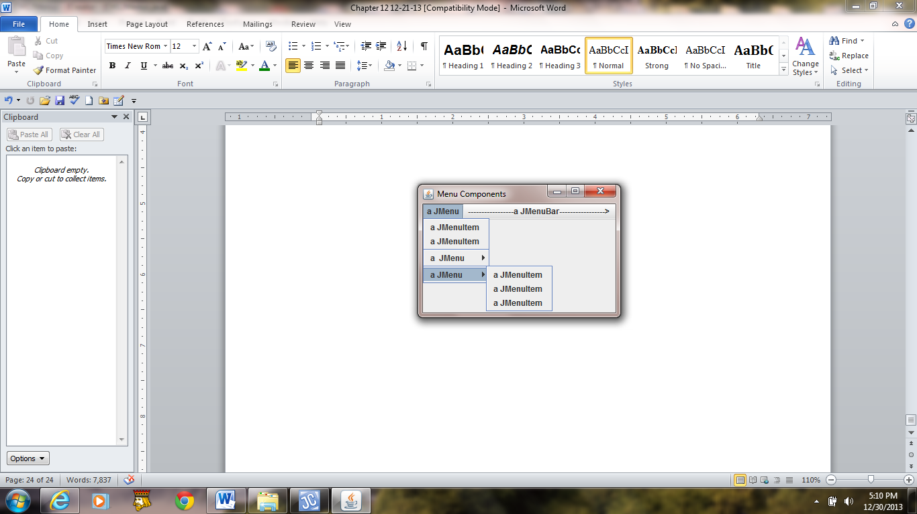

**a) b)**

**Figure 12.11 Drop-down menu components and their API classes.**